St. Patrick Catholic School 

The Importance of a Grateful Heart

Newsletter Vol. 2 No. 4 November 2022

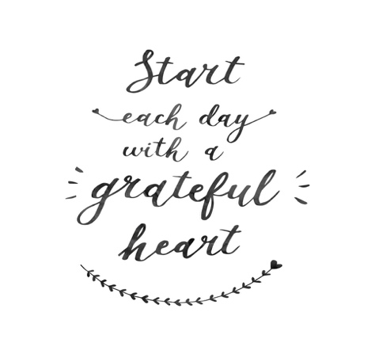
One of the things that I have learned over the last 40+ years of my life, is the importance of having a grateful heart. What do I mean? Let me explain.
A grateful heart is a heart full of gratitude for the things that God has done and continues to do in and through our life. It is the difference between a negative and positive attitude. It is also the only way that God can use our lives as a living testimony of His love, kindness, mercy, and grace. It is, in my opinion, the ONLY way to live.
For those of you reading this who share this same desire to create a thankful heart, home, school and parish it is imperative that we choose to be thankful each day.
There are countless ways, but here are a few ideas:

Be intentional.
Make sure that you CHOOSE to be thankful each day. Do this by meditating on scriptures.
Rejoice always, pray constantly, give thanks in all circumstances; for this is the will of God in Christ Jesus for you.
{1 Thessalonians 5:16-18}

Be a little more patient with your loved ones and friends each day.
Showing kindness and patience can make a HUGE difference in our relationships with our family members and friends. This shows God and your loved ones that you are grateful to God for blessing you with them.
Love is patient and kind; love is not jealous or boastful; it is not arrogant or rude.
{1 Corinthians 13:4}

Be quick to listen and slow to speak.
This shows God that we are thankful for the gift of hearing and able to be self-controlled. It also shows him {and those we are listening to} that we are grateful for the conversation and/or relationship we have with them. This not only honors God, but it also encourages those whom you are listening to that they are important and relevant.
Know this, my beloved brethren. Let every man be quick to hear, slow to speak, slow to anger.
{James 1:19}

Speaking the Word of God over your day.
This can be the single most important thing that you do as a family every single day. Depending on what you are going through, you can prayerfully find scriptures relevant for that season, and faithfully speak them over your family each day. God’s Word WORKS!
And let the peace of Christ rule in your hearts, to which indeed you were called in the one body. And be thankful.
{Colossians 3:15}

If we stop and look around, we have so much to be grateful for. Start with the little things, like the people who love you, the roof over your head, the food you eat each day and the fact that you have a heavenly Father who looks out for you all day, every day.

With you in Christ,
Autumn Carson

We are called to be humble and generous stewards.
Let’s use our gifts to bless those around us…
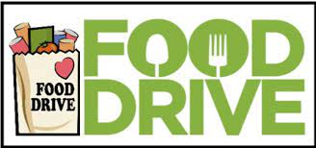
Food Drive

We will begin now and go through November 18th.
We will be hosting a food drive this month for the Labette County Emergency Assistance Center.
Here are the kinds of food we will be collecting: boxes: cereal, pancake mix, breakfast cereal bars, oatmeal; plastic jars: peanut butter, jelly, maple syrup; bags: cereal


SOCKS AND UNDERGARMENT DONATION

We will begin now and go through November 18th.
Socks and Undergarments will donated to the Youth Crisis Center. Items must be brand new and packaged.
Sizes needed:
Socks- kids small, medium to large, adult men’s size large and xlg.
Undergarments- Boys 8, 10-12, 14-16; men’s med., large, xlg.
Please encourage your child to ask family, friends, co-workers, neighbors and clubs for donations. With your assistance, we can help those in Labette County who most need it. Students will earn a free dress day for bringing items -Monday, Nov. 28th.

November & December
Monday, Oct. 31st –All Saints Day Parade and Parties @2:20
Tuesday, Nov 1st – All Saints Day – No School/Daycare- Mass 8am & 5:30pm
Wednesday, Nov. 2nd– 4th gr, visit VFW Americanism Day 9am-12pm
Sunday, Nov. 6th – Daylight Saving Time Ends-change your clocks!
Friday, Nov. 11th – Veterans Day
Thursday, Nov. 18th – Hearing and vision screenings
Monday, Nov. 21st-25th – No School -Thanksgiving Break – Daycare OPEN only - Mon. 21st & Tues. 22nd.
Wednesday, Nov. 30th – Religious Article Sale
Thursday, Dec. 8th – No School/No Daycare – Feast of the Immaculate Conception
Tuesday, Dec. 13th – Christmas Concert at the Parsons Municipal Auditorium
Friday, Dec. 16th – Early dismissal at noon – Christmas Break Begins!


The Gratefully Gathered Auction was a success! Thank you, dear parents and friends for your hard work and your generosity! Without your continued support of activities like the auction, students would not have many of the special things they do that make their school day a fun-filled learning experience. All of our Auction Committee are to be commended for their hard work and effort. The students and staff have benefited immensely from your dedication and service. We appreciate you!

